 

**Placement Empowerment Program**

***Cloud Computing and DevOps Centre***

Set Up a Virtual Machine in the Cloud Create a freetier AWS account. Launch a virtual machine and SSH into it.

Name: Mathimalar.P Department : ADS



**Introduction and Overview**

Setting up a virtual machine (VM) in the cloud allows you to create an isolated environment for running applications, testing, or developing software without the need for physical hardware. Using AWS's free-tier service, you can deploy a VM (known as an EC2 instance) to access and configure a cloud-based environment. SSH (Secure Shell) access enables you to securely connect to and manage this virtual machine remotely.

**Objective**

.

The objective of this task is to create a free-tier AWS account, launch an EC2 virtual machine, and connect to it via SSH. The steps involved include:

* Creating and configuring an AWS account
* Launching an EC2 instance using the free-tier options
* Generating SSH key pairs for secure access
* SSH-ing into the virtual machine to begin using it

.

Importance

Setting up a cloud-based virtual machine offers several advantages:

* **Cost-Effective** – AWS offers a free-tier service for newcomers, allowing users to try cloud computing without incurring costs.
* **Scalability** – Virtual machines in the cloud can easily scale up or down based on usage requirements.
* **Remote Access** – SSH enables you to securely connect to and manage the virtual machine from anywhere.
* **Testing and Development** – Cloud VMs are ideal for testing, deploying, and developing applications in a controlled, isolated environment.
* **Learning and Experimentation** – This process provides an opportunity to learn and experiment with cloud-based infrastructure.

**Step-by-Step Overview**

**Step 1**

1. Go to AWS Management Console.

2. Enter your username and password to log in

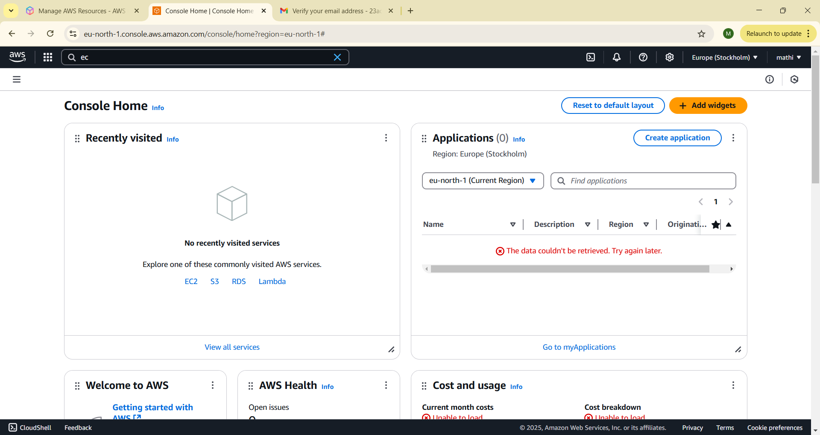

**Step 2**Navigate to the AWS Management Console and search for EC2.

**Step3** Click Launch Instances.

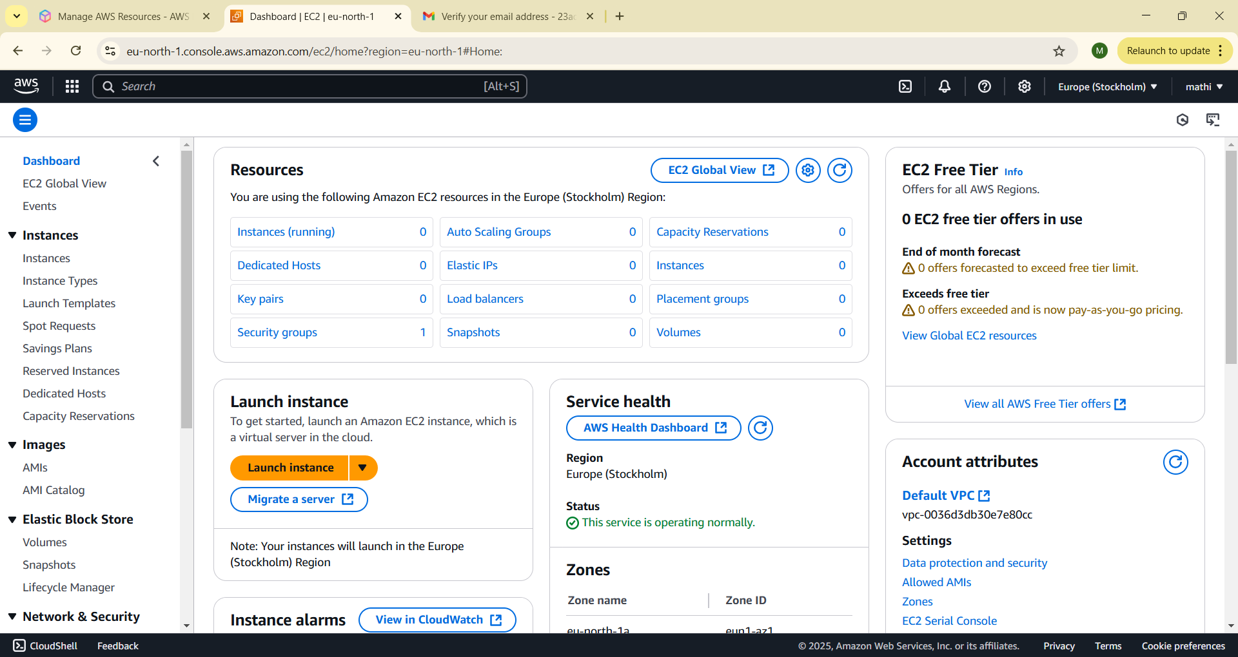

**Step 4:** :

1. Choose Amazon Linux 2023 Free Tier AMI or Ubuntu Free Tier AMI. 2. Select the t2.micro instance type (free tier).

3. Configure security group: Allow SSH (Port 22) from your IP.

4. Add a key pair: If you don’t have one, create a new key pair and download it as a .pem file.

5. Click Launch Instance

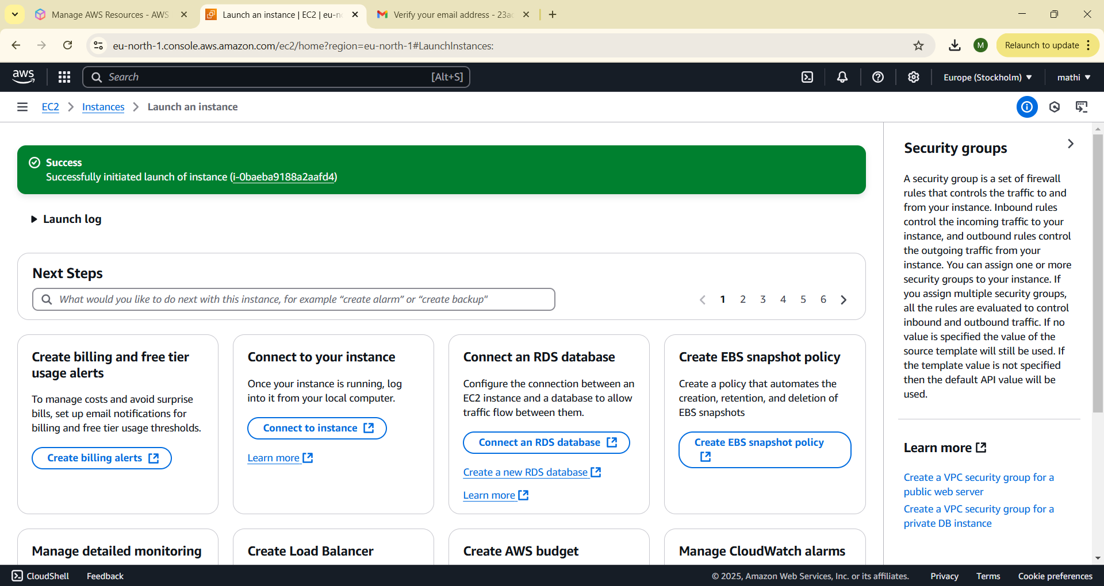

**Step 5:**

Check your running instance in the Instances section . Select your Instance and click the Connect Option.

**Step 6**

Check your running instance in the Instances section . Select your Instance and click the Connect Option.

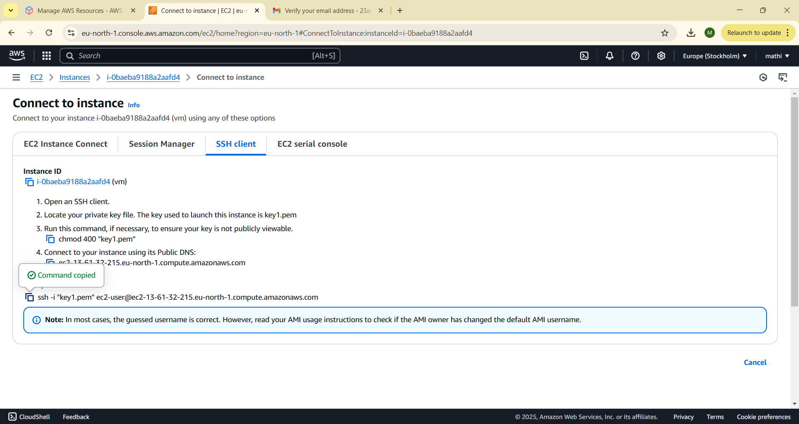

**Step 7:**

Open PowerShell, navigate to the Downloads folder. Run the SSH command from the EC2 Connect section, replace the key name with your downloaded key (e.g., new.pem), press Enter, and type yes when prompted.

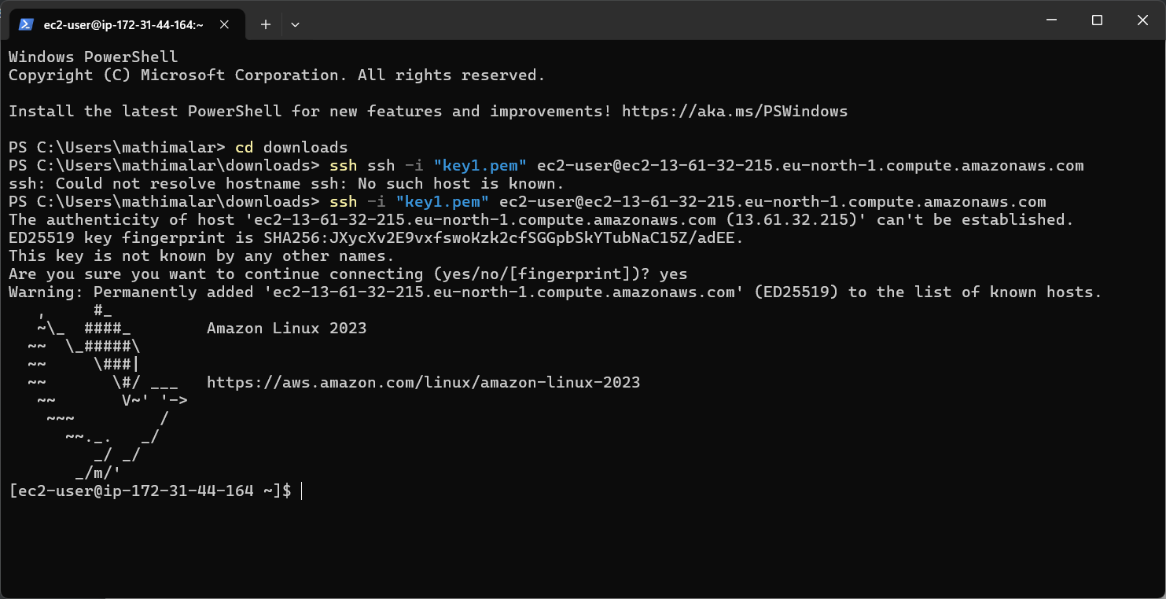

Successfully completed the setup of a virtual machine in AWS.

**Expected Outcome**

The successful setup of a cloud-based VM will result in:

* A fully functional EC2 instance running on AWS, accessible through SSH
* The ability to perform tasks such as deploying applications, managing services, or testing configurations remotely
* Hands-on experience with cloud infrastructure and remote system management